Date: 7/11/2017

Meeting committee:

* Dr. Chung
* Liz Hunter
* Richard Staple
* Alireza Khamesipour

Outline:

* SIU-ODIRS(Online-Degree Information Request System)
  + E-mail Auto-response
  + Text message Auto-response
    - How to choose the 3rd party company
* Web Server Management
* Website Speed
  + Indication
  + How to improve

SIU-ODIRS(Online-Degree Information Request System)

After the Information Request Form is submitted by a student(user), we want to be in touch with the student and provide them some useful information until the academic advisor reaches back to them. This helps the students make a better decision as well as reduces the work load on our staff.

For this purpose, we have worked on sending an auto-response email and auto-response text message. Different information can be sent through these technologies. We are limited to 140 characters per text message, therefore this could be a good way to link the students with our social media. We will have to have an active social media for this purpose.

An example of the E-mail auto-response looks like the following:

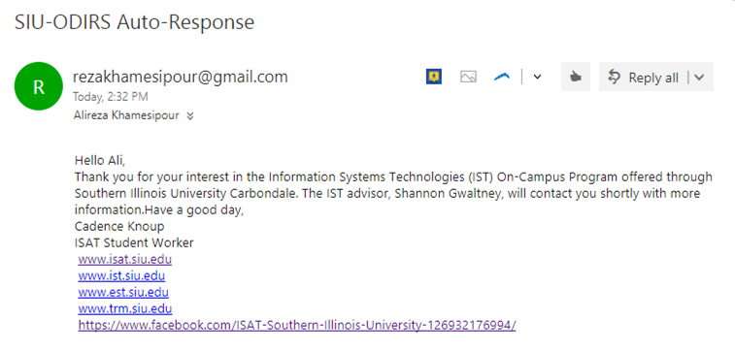

An example of our auto-response text messaging system is as follows:

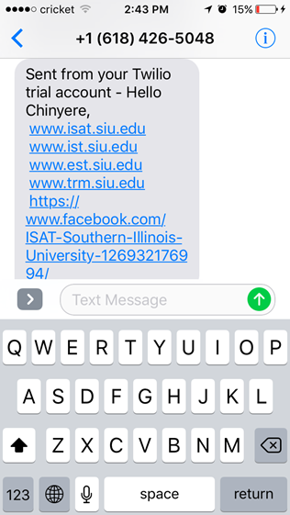

Selecting the proper 3rd party for sending text messages depends on a series of factors. Companies charge for sending SMS with different rates and different methods for charging. The could charge per SMS or per credit for example. Sending messages outside the country will use more credit than inside the country. Twilio, a 3rd party company offering cloud computing PaaS charges 7.5$ per 1000 SMS messages.

Our next goal is to have a cloud based web server. MongoDB Atlas offers the cloud based database system but we are looking for the whole web app to be cloud based.

MongoDB Atlas delivers the world’s leading database for modern applications as a fully automated cloud service with the operational and security best practices built in. Easily deploy, operate, and scale your databases across the leading cloud platforms.

The low speed of our website was a concern which will be fixed by the whole web server changing to a newer platform.

Liz was going to have a meeting next week to discuss about the software the undergraduate admission office was going to have installed and used for the school which could be capable of doing what the SIU-ODIRS is capable of doing.